Colney Heath Parish Council - Planning Applications for discussion at meeting – 16th May 2019
All applications submitted from Election 2nd May 2019

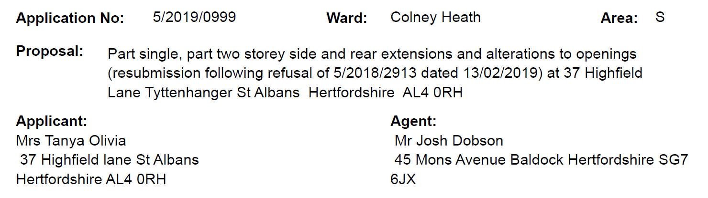
http://planning.stalbans.gov.uk/Planning/lg/dialog.page?org.apache.shale.dialog.DIALOG_NAME=gfplanningsearch&Param=lg.Planning&ref_no=5/2019/0999

Deadline for comments on this application is 24th May 2019

