

INVITATION TO TENDER FOR GRASS CUTTING CONTRACT FOR COLNEY HEATH PARISH COUNCIL April 2024 – March 2027

  - Postal Address: Highfield Park Visitor Centre, Hill End Lane AL4 0RA
 Telephone: (01727) 825 314
- Website: https://colneyheathparishcouncil.gov.uk
 E-mail: clerk@colneyheathparishcouncil.gov.uk

- Introduction

  - Colney Heath Parish Council (the Council) is seeking to award a three-year contract, April 2024 to March 2027. This contract is being procured under the Council’s open tender process.

  - You are invited to complete the attached Invitation to Tender (ITT) and to submit it together with any requested supporting information, to the Clerk, Highfield Park Office, Hill end Lane, St Albans AL4 0RA or by email to clerk@colneyheathparishcouncil.gov.uk by 5pm on 8th March 2024.

  - Potential Providers shall accept and acknowledge that by issuing this ITT the Council shall not be bound to accept any tender and reserve the right not to conclude a contract for the Services for which tenders are invited.

- Purpose and Scope

  - These instructions are designed to ensure that all potential providers are given equal and fair consideration. It is important therefore that you provide all the information asked for in the format and order specified.

  - The potential provider shall not contact any other employee or member of the Parish Council, who are in any way connected with this procurement exercise during the period of this procurement exercise, unless instructed otherwise by the Parish Clerk.

- Contract Term

  - The Contract shall be for a period of three (3) years from 1st April 2024 to 31st March 2027.

  - A review of the Contract, including price, will take place in October of each year.

  - It is anticipated that the Contract will be fully operational by 1st April 2024. Compliant with CHPC Financial Regs May 2023/24. Tender prepared by L Peters 09/01/2024 in conjunction with CHPC Standing Orders May 2023.

- Instructions for Completion

  - Potential Providers should read these instructions and the Specifications carefully before completing the Tender documentation. Failure to comply with these requirements for completion and submission of the Tender Response may result in the rejection of the Tender. Potential Providers are required therefore, to acquaint themselves fully with the extent and nature of the services and contractual obligations. These instructions constitute the Conditions of Tender. Participation in the tender process automatically signals that the potential provider accepts these Conditions of Tender.

- Tender Validity

  - Your tender should remain open for acceptance for a minimum period of 90 days. A tender valid for a shorter period may be rejected.

- Return of Tender

  - The completed questionnaire must be returned to the Clerk, Colney Heath Parish Council, no later than 5pm on 8th March 2024.

  - The Tender must be submitted in the form specified. Failure to do so may render the response non-compliant and it will be rejected.

- Disclaimers

  - Whilst the information in this ITT, Due Diligence information and supporting documents have been prepared in good faith, it does not purport to be comprehensive nor has it been independently verified.

  - Neither the Parish Council, the Clerk, or other employees:

    - Makes any representation or warranty (express or implied) as to the
accuracy, reasonableness, or completeness of the ITT; or

    - Accepts any responsibility for the information contained in the ITT or for
their fairness, accuracy or completeness nor shall any of them be liable
for any loss or damage (other than in respect of fraudulent
misrepresentation) arising as a result of reliance on such information or
any subsequent communication.

- Indicative Timetable

  - Set out below is the proposed procurement timetable. This is intended as a guide and whilst the Parish Council does not intend to depart from the timetable, it reserves the right to do so at any stage.

Procurement Stage | Deadline
Deadline for return of ITT to Parish Council | 8th March 2024
Evaluation of the ITT responses commences | w/c 11th March 2024
Issuing of recommendation report to Council | 15th March 2024
Decision of Parish Council | 21st March 2024
Awarding of Contract | 25th March 2024
Contract Start Date | 1st April 2024

- Eligibility, Selection and Award Criteria

  - In addition to price all tenders will be evaluated against the selection criteria set out in the table below.

Selection Criteria | Weighting
Health & Safety | 30%
Environmental Sustainability | 10%
Technical capacity, expertise, and experience | 50%
References | 10%
Total | 100%

- Contract Award

  - Contract award is subject to formal approval at the Parish Council meeting
which will take place at on 21st March 2024. Until all necessary approvals are obtained no agreement will be entered into.

  - The Parish Council shall be under no obligation to accept the lowest or any
tender.

GRASS CUTTING SPECIFICIATION

Key Aims
- To provide a good quality service, within agreed levels, which is fit for the purpose for which it is intended
- To ensure each site is left tidy

Specification of Work

To cut the recreation areas individually noted and pictured as follows:

1 | General Scope of work | The work involves cutting grass in public open spaces and amenity areas.
2 | Plant and Transport | The Contractor is to provide all tools, plant and cutting machinery, together with fuel etc. The Parish Council will not be liable for any damage to contractor’s equipment caused by carrying out these works. The contractor is to provide any equipment including transport which he requires to carry out the work
3 | Areas to be cut  Recreational & Common | Area 1 - Tyttenhanger Park  Area 2 – Roestock Park  Area 3 – Sleapshyde Park  Area 4 – Sleapshyde Village Green  Area 5 – Colney Heath Common
4 | Period of work | 1st April to 31st October each year of the contract
5 | Dates of Cutting | 6-15 cuts dependent by area. These dates may be varied by agreement with the Clerk having regard to growing conditions and any other material considerations. The Parish Council reserves the right to omit any cut or cuts and any area after year 1 of the contract at review times in October 2025 and October 2026.
6 | Mowing | The Contractor shall keep all grass areas mown using pedestrian operated or ride on rotary or cylinder mowers or strimmers.  Clippings may be left on and evenly distributed over the area.  Areas where spring bulbs are planted should not be mowed until the bulbs have died back sufficiently.  The grass on verges and other open spaces shall always be maintained at a height of between 15mm and 60mm.
7 | Strimming | On alternate grass mowing dates, it will be necessary for the contractor to strim round trees, lampposts, road signs, waste bins, dog bins etc, at least 8 times per year.
8 | Cleaning up after mowing | At the end of grass cutting operations, the contractor shall ensure that any grass cuttings or debris that have been distributed over roads, footpaths or other hard surfaces shall be swept up or blown on to grassed area
9 | Damage to Manhole Covers | Should a mower damage or move a manhole cover, then the contractor, where possible, is required to remedy the situation immediately. If this is not possible, the Contractor should inform the Clerk, who in turn will inform St Albans District Council or Hertfordshire County Council as appropriate. Any costs billed to the Parish for remedial work carried out by CHPC will be recharged to the contractor.
10 | Access to areas | If access is blocked or unable to be obtained for any reason a photograph of the blockage should be emailed to the Parish Clerk detailing the failed visit.
11 | Rectify | The contractor shall be required to recut, within 24 hours, any area deemed to be unsatisfactorily mown, at their expense.

GRASS CUTTING AREAS

RECREATIONAL

AREA 1 – TYTTENHANGER PARK (3 acres) (1.21 hectares)

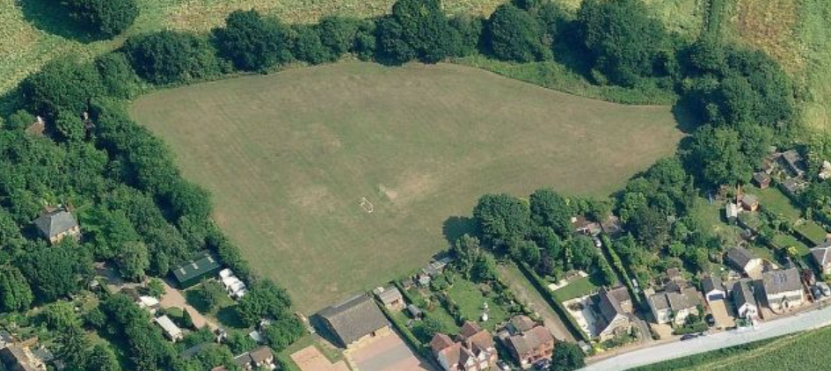

Postal Address: Tyttenhanger Park, Accessway between 19/25 Tyttenhanger Green, AL4 0RN

Specified monthly cuts – 15 cuts per season

The area to be cut is the playing field behind Charles Morris Hall and the access strip between numbers 19 and 25 Tyttenhanger Green (see accessway in photo below). Any goal posts to be cut around. Access will be from Tyttenhanger Green, between numbers 19 and 25 via a pathway and entrance gate. The Contractor will be supplied with a key to the padlock.

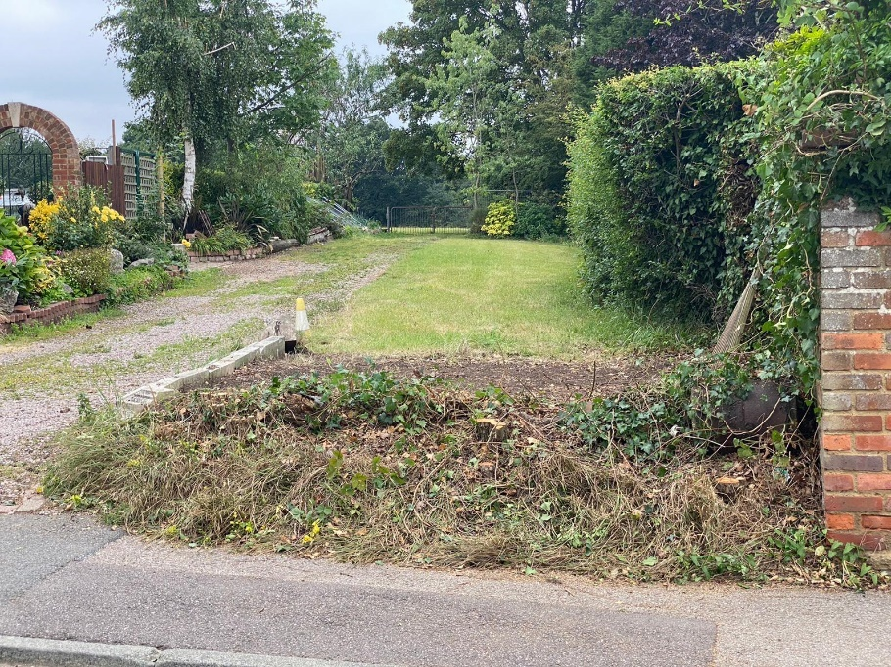

AREA 2 – ROESTOCK PARK (2.5 acres) (1.01 hectares)

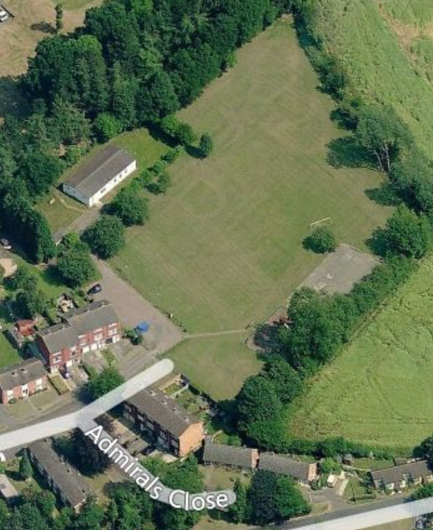

Postal Address: Admirals Close, Colney Heath, AL4 0QD

Specified monthly cuts – 15 cuts per season

The area to be cut is the entire recreation area. All benches to be cut around.

Access will be via Admirals Close, the entire area is protected by bollards, there are three bollards which lower into the ground and a key will be provided.

AREA 3 – SLEAPSHYDE PARK (0.77 acres) (0.31 hectares)

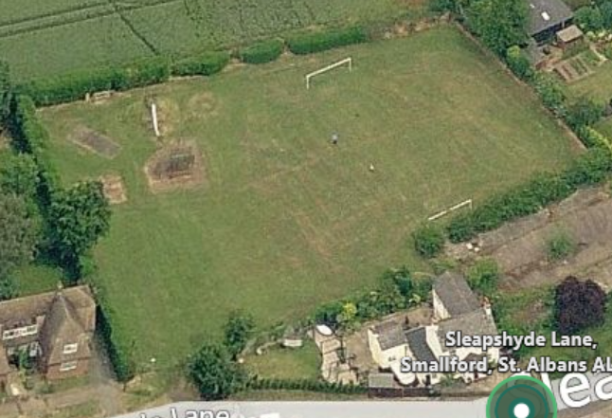

Postal Address: Sleapshyde Lane, AL4 0SD

Specified monthly cuts – 12 cuts per season

The area to be cut is the entire recreation area. All play equipment to be cut around including benches.

Access will be via roadway gate. Padlock on gate, key will be provided.

AREA 4 – SLEAPSHYDE VILLAGE GREEN (18 sq. yds.) (Approx 15 sq. mtrs) AND POND (5 sq. mtrs)
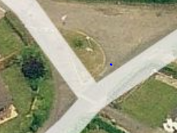
Secondary site will have to be seen on foot by contractor.
Postal Address: Sleapshyde Lane, AL4 0SD

Specified monthly cuts – 6 cuts per season

The area to be cut is the small semi-circle of grass in the picture above and the pond area accessed by a gate (not pictured) towards the top right corner of the picture.

GRASS CUTTING AREAS

Area 5 - COLNEY HEATH COMMON NATURE RESERVE

THE WARREN

FURZEFIELD PATH

PATHS & AMENITY GRASSLAND

5 per season in March/April, May/June, early September and October.

The Warren and Furzefield (along the track by Warren Farm) include a small piece of land at the start of the path OUTSIDE of the fenced grazing area. The path goes along the Southern boundary then along the Coursers Road boundary, all outside of the fencing. There is a limited turning area.

Contractor should ensure that when cutting paths and amenity areas that low ferns and shrubs are removed by cutting into the edges, particularly along the paths which run alongside the woodland and by the side of ‘The Rice’ takeaway shop at the High Street entrance to the Common.

The areas are shown in the attached Map shaded in orange.

MAIN COMMON

1 x 3” cut in September, all arisings must be removed.

The Contractor can cut and bale the grass for collection and use at their discretion except for 6 bales which are to be collected and used by local residents.

(The contractor should liaise with the Clerk and Common Ranger concerning management of any ragwort). The areas are shown in the Map shaded in green

ALL AREAS

There are stands of scrub and woodland, shown in the Map shaded in blue, these will be managed over the next few years. Meanwhile the areas must be mown as close as possible to the scrub to prevent any further encroachment.

Tender Response
TENDER FOR GRASS CUTTING CONTRACT FOR COLNEY HEATH PARISH COUNCIL
April 2024 – March 2027

Tenderers are to complete Parts A, B, C and D and return either by email or post as directed

PART A

COMMERCIAL INFORMATION

A.1. Company/Organisation identity:

A.1.1 Company name of organisation submitting the tender:

A.1.2 Contact name and position in organisation:

A.1.3 Company address:

A.1.4 Contact Telephone number:

A.1.5 Contact e-mail address:

A.1.6 Company Web Site Address:

A.2 Areas of Business

A.2.1 Please indicate below the principle areas of business activity of your organisation

A.2.2 Please indicate which elements if any of the services your organisation anticipates may be sub-contracted:

A.3 Insurance

A.3.1 Please provide a copy of your organisation’s insurance certificates and provide the required information regarding your company/organisation’s insurance cover:

Public Liability Insurance Minimum £5,000,000.00
Insurer
Policy Numbers
Expiry Date
Limits of Indemnity (per occurrence and aggregate)
Excess (if any)
Employers Liability Insurance Minimum £10,000,000.00
Insurer
Policy Numbers
Expiry Date
Limits of Indemnity (per occurrence and aggregate)
Excess (if any)

A.4 Health and Safety

A.4.1 Please supply the name and designation of the person responsible for the implementation of the organisation’s Health and Safety Policy.

A.4.2 If you employ 5 or more employees, please enclose a copy of your current Health and Safety Policy.

A.4.3 If you employ less than 5 employees, please tell us how you ensure that your Health and Safety measures are put in place and practiced within your organisation.

A.5 Environmental Sustainability

A.5.1 Please enclose a copy of any environmental management certification that your organisation holds. If you do not have any certification, please detail how your organisation complies with environmental legislation.

PART B

TECHNICAL CAPABILITY

B.1 Previous Experience

B.1.1 Please provide information of your organisation’s technical capability, expertise and experience over the past five years of carrying out similar services under a formal contract to the public sector, parish councils or other public bodies.

B.2 Staff Skills and Development

B.2.1 Please indicate below whether any operatives you employ and expect to engage on this contract have specific skills/qualifications related to the range of requirements set out in this tender document.

Skill/Qualification | Number of Operatives

B.2.2 Please provide details of your current training policy/procedures (including any health and safety training) and describe how you ensure that skills are maintained.

B.3 References – please provide 2 references

B.3.1 Please provide details for two companies/organisations for which you have carried out similar works.

Reference 1

Company Name
Company address
Contact Name
Contact Phone number
Contact e-mail address
Contract start / end dates
Contract value
Brief description of contract

Reference 2

Company Name
Company address
Contact Name
Contact Phone number
Contact e-mail address
Contract start / end dates
Contract value
Brief description of contract

PART C

TECHNICAL PROPOSAL

C.1 Service Requirements

C.1.1 Please detail below the format in which your organisation can receive Service Requests

C.2 On-site Arrangements

C.2.1 What arrangements does your organisation have for the removal and recycling of any rubbish and debris accumulated during the supply of the services?

C.3 Quality of work and Supplier conduct
C.3.1 Please detail the checks that your organisation will make to ensure that the services will be carried out by a suitably trained and competent team / member of staff.

C.4 Sub-Contracting
C.4.1 Please detail your organisation’s methodology for employing sub-contractors and ensuring that sub-contractors if used are fully compliant with the terms and conditions of the Framework Agreement.

PART D

FINANCIAL PROPOSAL

D.1 Schedule of Charges

 | Price per cut | Price per year
Area 1
Tyttenhanger Park & Accessway
Area 2
Roestock Park
Area 3
Sleapshyde Park
Area 4
Sleapshyde VGreen & Pond
Area 5
The Common – cut and bale
Area 5
The Common – Furzefield paths & amenity grassland

Total contract value exc. VAT

D.2 Form of Tender

TO BE COMPLETED BY THE TENDERER

To: Colney Heath Parish Council

PROVISION OF GRASS CUTTING SERVICES FROM 1st APRIL 2024

From:

Having examined the Invitation to Tender and all other Schedules, and being fully satisfied in all respects with the requirements of the ITT (including the Conditions of Tender) for the above mentioned services, I/We hereby offer to provide the whole of the services for the term of three (3) years from the Date of Commencement stated above with conformity with the Conditions of Contract and Methods of Work, Specifications and the Pricing Documents for the prices in the Pricing Documents.

I/We understand that you are not bound to accept the lowest or any tender you receive.

I/We understand that no payment will be made for any expenses or losses incurred in the preparation of my/our tender.

I/We agree that this tender remain open for acceptance for 90 days after the closing date for submission.

I/We warrant that I/we have all the requisite corporate authority to sign this Tender.

Signed: …………………………………………………………………….

For and on behalf of: …………………………………………………………………………

Address:……………………………………………………………………………………

…………………………………………………………………………………………………

Date: …………………………………………………………………………………………..

